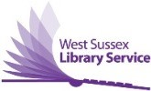
Census Support Service in West Sussex Libraries
West Sussex Libraries are part of the national Census Support Service. Library staff can help support residents who live in Adur, Worthing, Arun and Chichester to complete their census forms online.
As libraries are currently not open for browsing or computer use, we can complete the form online for residents over the phone. To book an appointment with one of our staff, who are all trained Census Support Advisors, phone 0330 222 3455 Monday to Friday between 10.00am – 4.00pm.

